1. **Experiment:** Sequence design
2. **Time:** 2024.10.05-2024.10.13
3. **Member:** Fan Yang, Qiwen Jiang, Xinxin Zhang, Kaiqing Zhang, Meng Sun
4. **Method:**
5. In this study, a homologous recombination strategy was employed for the experimental design. The selected peptide sequences, namelyB0, B34, B51 and G9, G16, G35, G42, G57, G71, along with their corresponding reverse sequences, were conjugated via a flexible linker. Reverse sequences were incorporated due to the flexibility of peptide linker and the inherent directionality of protein-receptor binding. Furthermore, glycosylphosphatidylinositol a (GPI) membrane-anchoring sequence was fused to the construct to retain the IL-2 mimetics on the cell surface rather than their secretion into the extracellular space, facilitating activation of NK cells. Additionally, Flag tag was coupled with the recombinant sequences for subsequent detection and isolation purposes.
6. The specific sequences of the genetic elements are listed in the table below.

**Table.1** β binder

|  |  |
| --- | --- |
| **β binder** | **Sequence** |
| B0 | MEEKLEELKKKLAELDGKYIYEKCYGTEEEAKKALEELKAALEELAKAEKEAAAAAA |
| B34 | AAEAARRAARAAFDARLTAAERKYLAAQDDPEAAAAWLAEIAAIEAERTAAERAWAA |
| B51 | EEERRRQIEALKRAAAAAEYEYALAKELAAKDPAYAPLAEALKAELERLKAELAALEAA |

**Table.2** γ binder

|  |  |
| --- | --- |
| **γ binders** | **Sequence** |
| G9 | SAAAKEAAKALATALRLAGTRLFTAGAVAAKIDPAAGAALFAAGAAAFAAAAALEKALA |
| G16 | MSLAEAIRDAGVAAALASGDPAHLDAAKAAIAAAVSPEEAARWAAVLDEDYARARAAAA |
| G35 | AAEEEAERLRRAAAELAERLARAALLAALRAALAARLAANALKIAAAAAALAAAAA |
| G42 | YLEEAVAALKKLRDDLAAQLAKAKAAADTPEMKALAAETQALLELATKQLEKAEAKLK |
| G57 | EELARLAEELAAARREALRAELEALRREQEERLREEEEERRRREEEEK |
| G71 | DVATLKALAAQYRAARAAVREEAARLAAAEPERAAEILAEGAALAAAFDAKAAAAAAAAAAAA |

**Table.3** Recombinant Elements

|  |  |
| --- | --- |
| **Name** | **Sequence** |
| β-Homology Arm | AGCTGTGACCGGCGCCTACT |
| β-Restriction Enzyme  Cutting Site | CTAGA |
| Signal Peptide（SP） | ATGGCCCTGTGGATGAGACTATTGCCACTGCTTGCCCTGCTCGCACTGTGGGGTCCCGATCCTGCTGCCGCA |
| FLAG | GACTACAAGGACGACGACGACAAG |
| Glycosylphosphatidylinositol（GPI） | GGAGGCACCTCTCTGTCCGAGAAGACAGTGCT  GCTGCTGGTGACACCATTTCTGGCCGCCGCAT  GGTCTCTGCATCCATGA |
| γ-Restriction Enzyme  Cutting Site | GGATC |
| γ-Homology Arm  BamHI  Xbal | CGCGGCCGCTGAGGGCAGAG  GGATCCGCTAGCCCCGGGGCGGCCG  TTGACCTCCATAGAAGATTCTAGA |

1. **Result:**

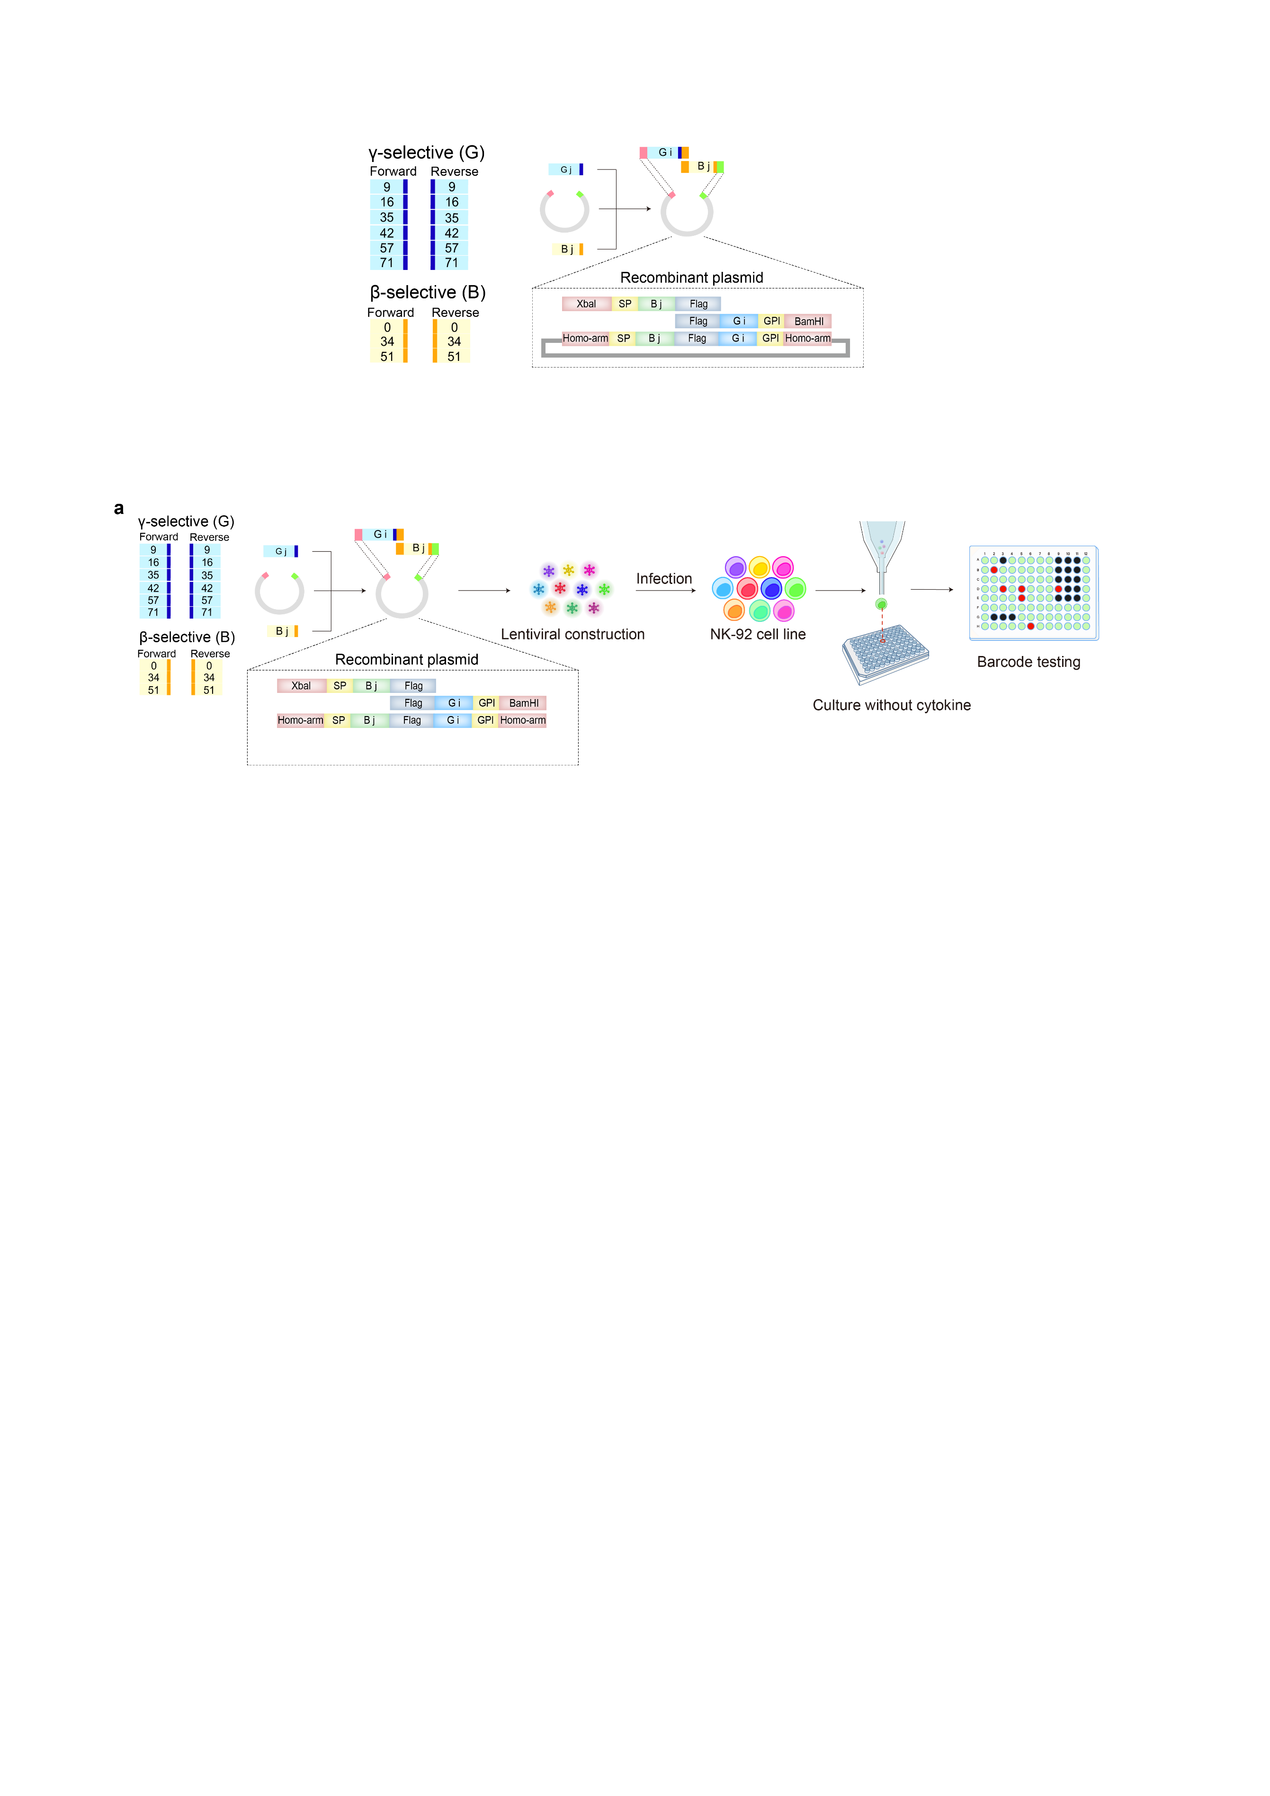

**Figure.1** Construction and screening of IL-2 mimics library. Twelve IL-2Rβ binding mimics six IL-2Rγ mimics form 72 combinations.